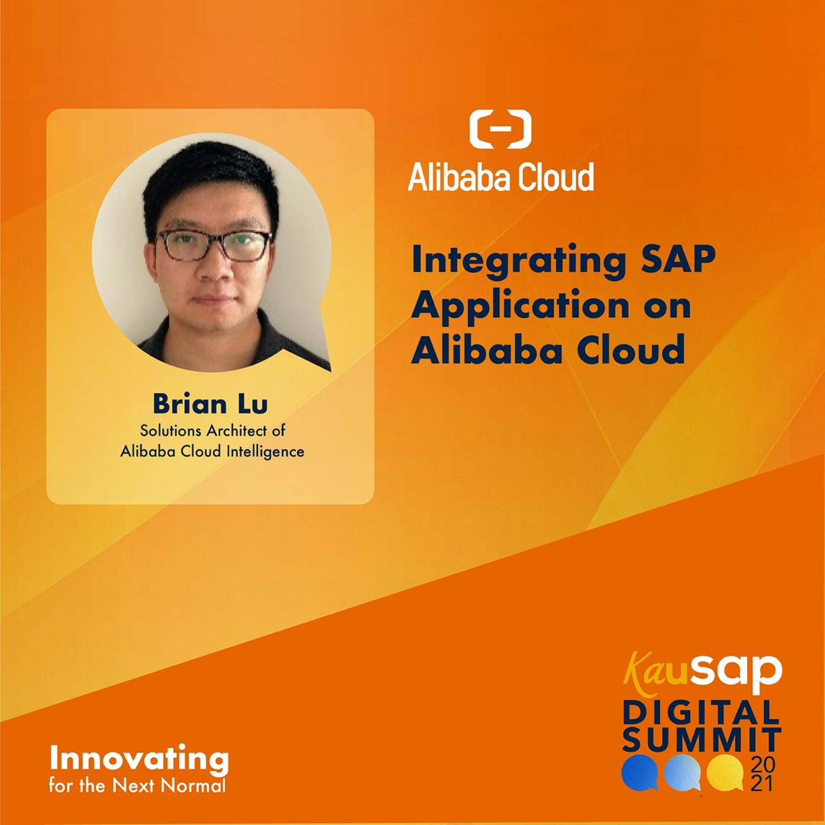

Brian Lu is a Solutions Architect of Alibaba Cloud Intelligence. Brian plays a vital role in the customers' cloud adoption journey, and is an expert in SAP solutions on Alibaba Cloud, pre-sales support, and related ecosystem developments towards digital transformation.

Alibaba Cloud is a trusted partner of SAP, offering the reliability and security that your business requires. The mature service infrastructure and platforms of Alibaba Cloud, when combined with the world-leading applications and Database Management System (DBMS) services of SAP, can help to simplify your overall IT infrastructure and
accelerate the digital transformation of your enterprise.

